

Addis Ababa Science and Technology University

    College of Mechanical  and Electrical Engineering

    Department of Software Engineering

 Simulation and Modeling individual Assignment 1

The Weibull probability Distribution.

Submitted by : Henok Zelalem ETS 0626/10

Submitted to: Hayelom M. (PhD Candidate at UESTC)

June 2021

Table Of Content

Introduction 1

When Use Weibull probability distribution 1

Weibull Distribution Formulas 2

Two-Parameter Weibull Distribution 2

Weibull Plot 3

Weibull Distribution Reliability 3

Weibull Distribution Properties 3

Inverse Weibull Distribution 3

Examples 3

References 5

**Weibull Probability Distribution**

# **Introduction**

The Weibull distribution is named after the Swedish engineer and scientist Ernst Hjalmar Waloddi Weibull (1887–1979). He did not discover it but instead popularized the distribution in his 1951 paper to the American Society of Mechanical Engineers. The distribution had previously been studied by French mathematician Maurice Fréchet in the context of extreme value distributions, and was used many years earlier by Rosin and Rammler to model the grain size distribution of ground coal. For this reason, the Weibull distribution is sometimes called the Rosin–Rammler distribution.

The Weibull Distribution is a continuous probability distribution used to analyze life data, model failure times and access product reliability. It can also fit a huge range of data from many other fields like economics, hydrology, biology, engineering sciences. It is an extreme value of probability distribution which is frequently used to model the reliability, survival, wind speeds and other data.

# **When Use Weibull probability distribution**

Weibull distribution has proven quite successful in predicting the occurrence of extreme phenomena like floods, earthquakes, high wind speeds and torrential rains. Also, because the Weibull distribution is derived from the assumption of a monomial hazard function, it is very good at describing survival statistics, such as survival times after a diagnosis of cancer, light bulb failure times and divorce rates, among other things.

The properties of the Weibull distribution are best described in terms of the hazard function. This tells us how likely something is to fail given that it has survived so far. A simple power law is used for the hazard function, which accommodates three distinct behaviors:

* if something is going to fail it will most likely fail at the start;
* the rate of failure is fairly constant;
* failure becomes more likely as time goes on.

# **Weibull Distribution Formulas**

The formula general Weibull Distribution for three-parameter pdf is given as

f(x)=γα((x−μ) α) γ−1exp (−((x−μ) α) γ )   x≥ μ; γ,α>0

Where:

* γ is the shape parameter, also called as the Weibull slope or the threshold parameter.
* α is the scale parameter, also called the characteristic life parameter.
* μ is the location parameter, also called the waiting time parameter or sometimes the shift parameter.

The standard Weibull distribution is derived, when μ=0 and α =1, the formula is reduced and it becomes

f(x)=γxγ−1exp(−x) γ, x≥0; y>0

# **Two-Parameter Weibull Distribution**

The formula is practically similar to the three parameters Weibull, except that μ isn’t included:

f(x)=γα((x)α)γ−1exp(−((x)α)γ)   x≥0

The failure rate is determined by the value of the shape parameter γ

* If γ < 1, then the failure rate decreases with time
* If γ = 1, then the failure rate is constant
* If γ > 1, the failure rate increases with time

# **Weibull Plot**

The fit of Weibull distribution to data can be visually assessed using a Weibull plot. In other words, it is a graphical method for showing if a data set originates from a population that would inevitably be fit by a two-parameter Weibull distribution where the location is expected to be zero. This plot has unique scales that are designed so that if the data do support a Weibull distribution, the points will be linear or approximately linear. The least-squares fit of this line generates estimates for the shape and scale parameters of the Weibull distribution. In this case, the location is assumed to be zero examples:

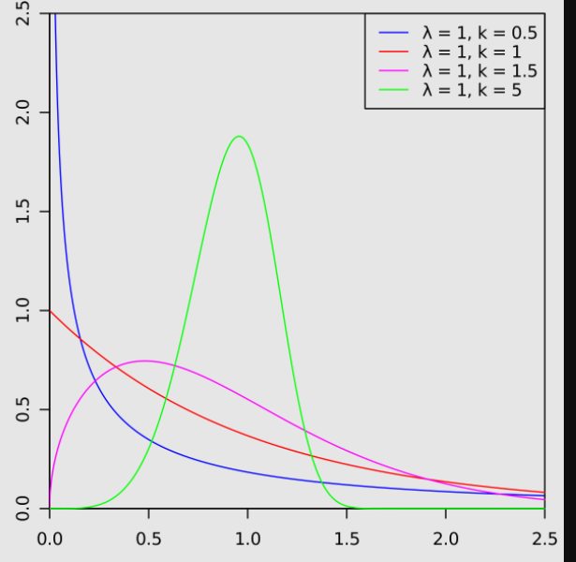

# **Weibull Distribution Reliability**

The Weibull distribution is mostly used in reliability analysis and life data analysis because of its ability to adapt to different situations. Depending upon the parameter values, this distribution is used to model the variety of behavior for a particular function. The probability density function usually describes the distribution function. The parameters in the distribution control the shape, scale and location of the probability density function. Several methods are used to measure the reliability of the data. But the Weibull distribution method is one of the best methods to analyses life data.

# **Weibull Distribution Properties**

Some properties of Weibull distribution are:

* Probability density function
* Cumulative distribution function
* Moments
* Moment generating function

# **Inverse Weibull Distribution**

The inverse Weibull distribution has the ability to model failures rates which are most important in the reliability and biological study areas. Like Weibull distribution, a three-parameter inverse Weibull distribution is introduced to study the density shapes and failure rate functions.

The probability density function of the inverse Weibull distribution is given as

f(x)=γαγx−(γ+1)exp[−(αx)γ]

# **Examples**

Weibull analysis can be used to study:

* Utility Services
* Warranty Analysis
* Components produced in a factory (like bearings, capacitors, or dielectrics),
* Analyses the lifetime of dental and medical implants
* Other areas where time-to-failure is important.

# **References**

<https://rss.onlinelibrary.wiley.com>

<https://byjus.com/maths/weibull-distribution>

<https://www.sciencedirect.com/topics/engineering/weibull-probability-distribution>